Homework #6
EE:4077 Fundamentals of Machine Learning

1 EM [25 points]
Suppose X₁,...,X_{N} are i.i.d random variables with the density function f_{X}(x,λ) = λe^{−λx}, for x ≥ 0 and 0 otherwise. We observe Y_{i} = min{X_{i},c_{i}} for some fixed and known c_{i}. In this problem, you will estimate the value of λ using the EM algorithm. In particular, the variables X_{i}’s correspond to the missing or latent variables.
- Show that the log-likelihood L(X₁,...,X_{n}|λ) in terms of the latent (unobserved) variables X_{i} is
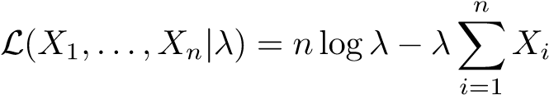.
- What is the conditional expectation of X_{i} assuming that you observe Y_{i} = y_{i} < c_{i}?
- Now suppose that Y_{i} = c_{i}. What is the conditional expectation of X_{i} given that you observe Y_{i} = c_{i}? Hint: You may want to use the memorylessness property of the exponential distribution.
- Suppose we observe y₁,...,y_{N}. Let I_{i} be an indicator denoting if y_{i} < c_{i}. In other words, I_{i} = 1 if y_{i} < c_{i} (as in part (b) above)), and I_{i} = 0 if y_{i} = c_{i} (as in part (c) above). After t rounds of the EM algorithm, we have got an estimator λ^{t}. Using your results from parts (a), (b), and (c) above, write down the E-Step for the t + 1st round, i.e., derive Q(λ|λ^{t}) = E[L|y,λ^{t}].
- Now write down the M-Step from the t + 1st round and calculate the value of λ^{t+1}.

3-Dimensional Principal Component Analysis [25 points]
In this problem, we will perform PCA on 3-dimensional data step by step. We are given three data points:
x₁ = [0,−1,−2],x₂ = [1,1,1],x₃ = [2,0,1],
and we want to find 2 principal components of the given data.
- First, find the covariance matrix C_{X} = X^{T}X where $X =\left[\begin{matrix}x1 \\ x2 \\ x3\end{matrix}\right]$. Then, find the eigenvalues and the
corresponding eigenvectors of C_{X}. (Feel free to use any numerical analysis program such as numpy, e.g., numpy.linalg.eig can be useful. Also make sure to center the data X first.)
- Using the result above, find the first two principal components of the given data.
- Now we want to represent the data x₁,··· ,x₃ using a 2-dimensional subspace instead of a 3-dimensional one. PCA gives us the 2-D plane which minimizes the difference between the original data and the data projected to the 2-dimensional plane. In other words, x_{i} can be represented as:
xei = ai1u1 + ai2u2 + b3u3, (1)
where u₁ and u₂ are the principal components we found in 3.b., and u₃ is a vector orthonormal to u₁ and u₂. Figure 1 gives an example of what this might look like.
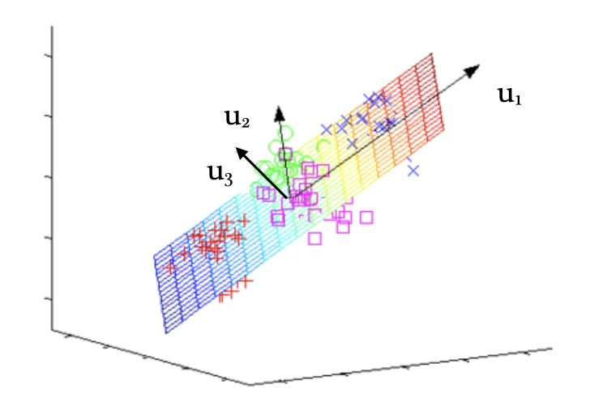
Figure 1: Example of 2-D plane spanned by the first two principal components.
Find a_{i1},a_{i2} for i = 1,2,3 and b₃. Then, find the ${\hat{x}}_{i}$’s and the difference between ${\hat{x}}_{i}$and x_{i}, i.e., ||${\hat{x}}_{i}$− x_{i}||² for i = 1,2,3. (Again, feel free to use any numerical analysis program to get the final answer. But, show your calculation process.)
Hint: b₃ can be easily obtained from $\overline{x}=\frac{1}{3}(x_{1}+x_{2}+x_{3})$
3 GMM [25 points]
In this problem, we have a dataset that has K components {C₁,C₂,...,C_{K}}. Each component is generated from a normal distribution ∼ N(µ_{i},Σ_{i}). In other words, each data point x is generated as follows:
- Choose a component y = 1,2,...,K with a probability P(y = i) = π_{i} for i = 1,2,...,K.
- Draw a sample x ∼ N(µ_{i},Σ_{i}).
Note that our dataset therefore satisfies the assumptions of a Gaussian mixture model. Now we can find the following probability distributions of x:
p(x|y = i) ∼ N(µ_{i},Σ_{i}), p(x) =$\sum_{i=1}^{K}{p(x|y = i)P(y = i).}$

At test time, we wish to assign a cluster to each data point x. We can do so by finding the component that yields the maximum probability for the test point x:
argmax_{k} p(y = k|x)

Now suppose that we are given a set D of N example data points, each consisting of a d dimensional vector. More formally, our data D = {x₁,x₂,x₃ ...x_{N}} where each x_{i} ∈ R^{d}. Our task is to assign each example into one of the K clusters using the above formulation. The parameters for the above formulation are θ = (π₁,π₂ ...π_{K},µ₁,µ₂ ...µ_{K},Σ₁,Σ₂ ...Σ_{K}), hence the problem reduces to estimating these parameters.
Dataset In the file gmm data.txt, each row is a unique vector of 5 dimensions. There are 3000 unique examples. Hence N = 3000,d = 5, and we want to group these points into three clusters (K = 3). They are generated as per the generation process outlined above. To visualize the dataset, we have plotted the first 2 dimensions (i.e x_{i1},x_{i2} ) of each i from 1 to 3000 (Figure 2)
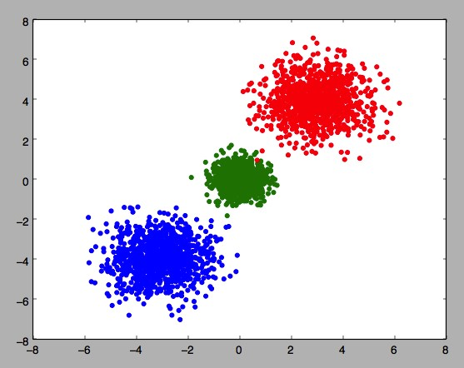
Figure 2: The first two dimensions of the dataset, different colors denote different clusters.
Convention For consistency, we refer to the leftmost cluster (i.e., one with the least µ_{i1}) as the Blue cluster (denoted by blue color), the middle cluster as the Green cluster (denoted by green color), and the rightmost (the one with the largest µ_{i1}) cluster as the Red cluster (denoted by red color). Figure 2 also adheres to this convention.
Problems Now, please answer the following questions. Please include your code in the final PDF you turn in for full credit.
- Assuming that Σ_{i} = σ_{i}²I, compute and write below the means µ₁,µ₂,µ₃ and the standard deviations σ₁,σ₂,σ₃. We highly recommend that you use the GaussianMixture model from sklearn. (Please use random initialization for this part, and a default convergence threshold/tolerance of 0.001)
- From these computed means and std. deviations, cluster all the 3000 points, and plot three figures
  - Plot the first two dimensions (x_{i1},x_{i2}) with their cluster assignments. (similar to Figure 2) – Plot the third and fourth dimensions (x_{i3},x_{i4}) with their cluster assignments.
  - Plot the fourth and fifth dimensions (x_{i4},x_{i5}) with their cluster assignments.
- For this subquestion, you are not permitted to use any library function that performs the EM algorithm, and you are instead supposed to write your own EM algorithm to estimate the means µ₁,µ₂,µ₃. You can assume that values of π₁,π₂,π₃ and σ₁,σ₂,σ₃ are known and reuse the values that you computed in part (a) (They can be found in GaussianMixture.weights and GaussianMixture.covariances ). Write down your E-step and M-step to estimate µ₁,µ₂,µ₃. For the programming, please use a convergence threshold/tolerance of 0.001.
- We now relax the assumption that π₁,π₂,π₃ are known. Modify your EM algorithm to simultaneously estimate means µ₁,µ₂,µ₃ and the component probabilities π₁,π₂,π₃. You can still assume that σ₁,σ₂ and σ₃ are known and use their values from the solution above. Write down your E step and M step. For the programming, please use convergence threshold/tolerance of 0.001. For this part too, you are not permitted to use library functions that perform EM algorithm.

